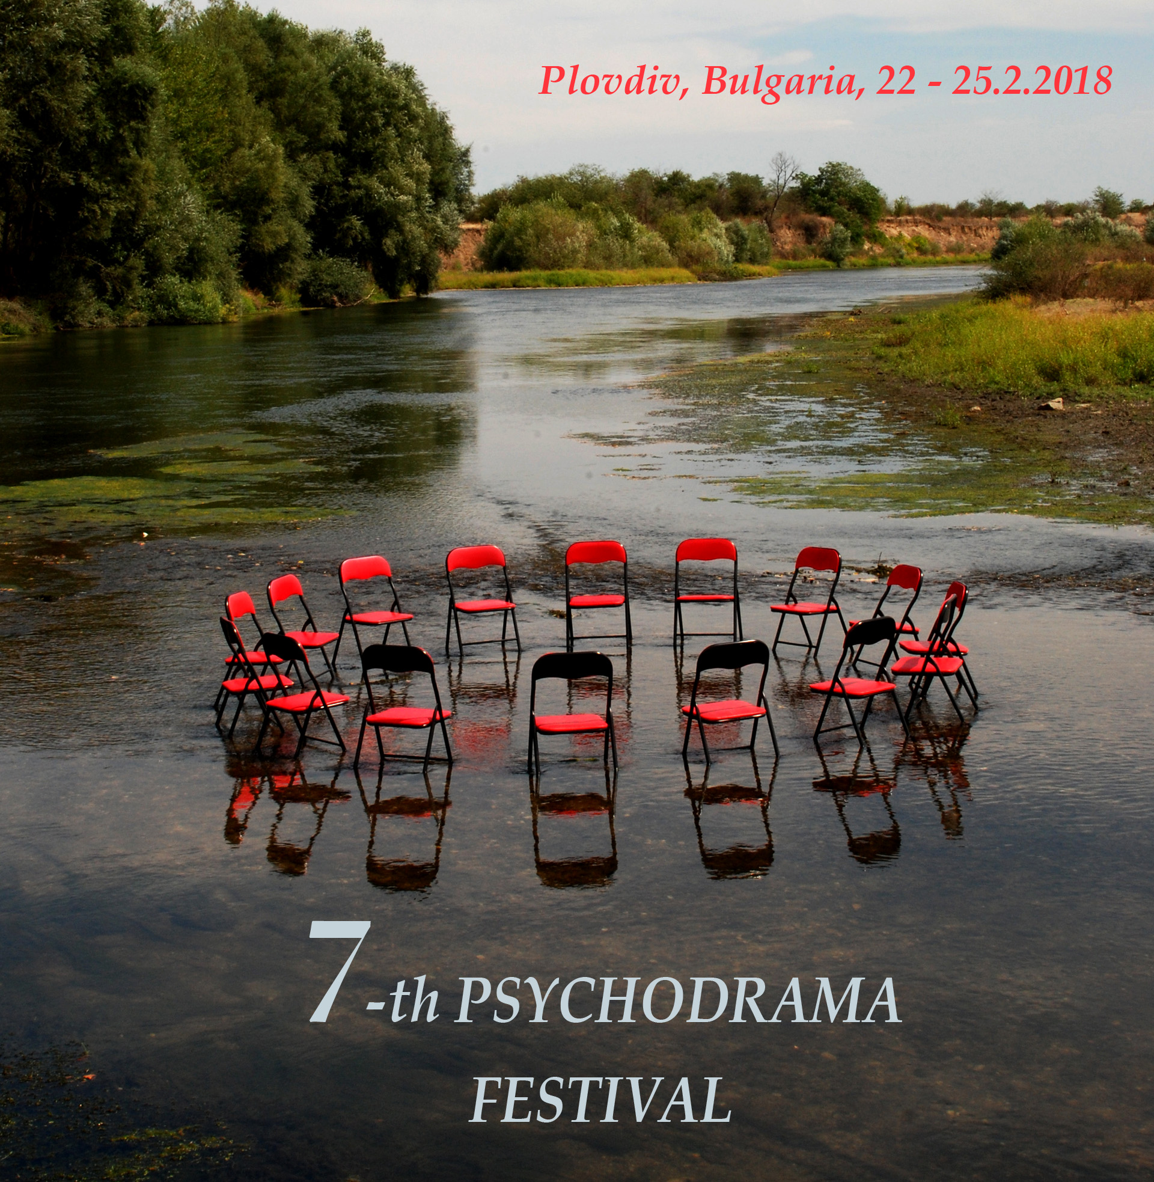
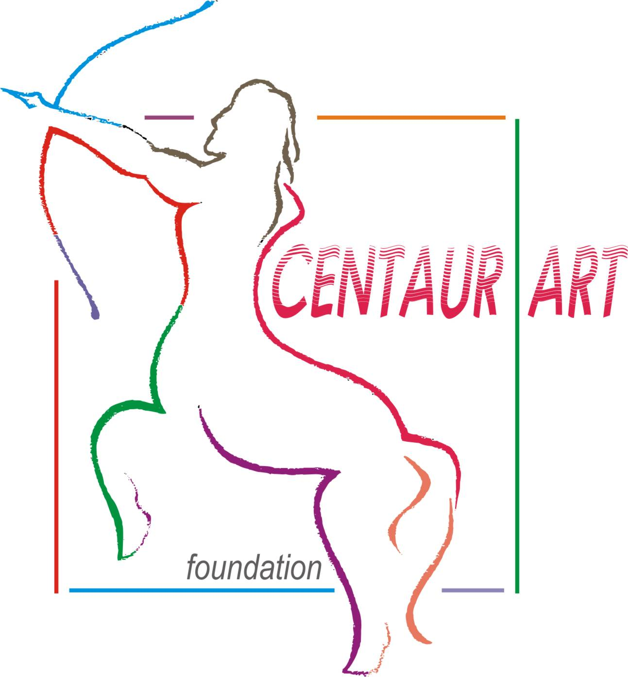

…
“Psychodrama … also is a technology for addressing human problems that need creativity and some inclusion of the feelings of the people involved. It’s a technology that aims at promoting creativity using improvisation, enactment, and creative collaboration…
…We have been taught that what needs to be known is established, has been learned, and just needs to be studied. Improvisation implies going outside the boundaries of that box, disrespect for authority. But the world is changing and exploring more creative approaches is not disrespect for the past so much as a simple recognition that the past cannot supply all the answers…”
Excerpt of a letter to the Centaur Art Foundation by Adam Blatner - a psychiatrist, psychodrama therapist and trainer, author.
…
Psychodrama-Festival - Plovdiv city is an opportunity to explore different fields of psychodrama - both in terms of the individuals and groups with which the psychodrama works, as well as the techniques and formats used by psychodrama.
…
“…Every festival it has its own mood, atmosphere, brought particle by particle with each participant and presenter, amateur and spectator of evening events, joining in one-word, sentence, emotion….
In the Fourth Festival in 2015, as if the main word was sadness. In the fifth Festival in 2016 - Fairy scene.
In the Sixth Festival held 16-19.03.2017 - Light silence. No words…”
Inna Braneva - psychodrama therapist and trainer
…
Psychodrama is a universal language in which roles and experiences can connect people of different social and ethnic groups, different ages, in different states - as long as they have an interest in participating, even as an audience.
…
“…It seemed like almost everyone knew where and why they came, and they looked satisfied with their choice. As if, we all together have climbed the hill. And together we touched the authentic essence of the Psychodrama Festival…”
Konstantin Banderov - psychodrama leader
…
This quality of psychodrama, being a connecting language, opens up space for work on terrain in different spaces and conditions. Through it we often work with marginalized groups; at risk; with children and teenagers; in schools, in social institutions; with people who have difficulty connecting in a different way: due to some form of discrimination or reverse segregation; due to strong internal and external conflicts. In the individual's main difficulty to connect with oneself, to "see" from within, to understand and to show tolerance to himself.
…
“…You are the playwright and the actor. Now you don’t want to play life anymore. You want to live it. No more drama in your psycho. You are reborn.
You can start your new play now…”
Konstantin Kuchev - presenter in the Sixth Psychodrama Festival
…
Different practices and experiences of professionals are interweaved and shared in the Psychodrama Festival, including those working with other methods but having a point of contact with psychodrama: art and music therapy, dance therapy, drama and role-play therapy, playback theatre, group and individual therapy, social and educational work, business and management, and others.
…
“…My last sentence want to be about something very touchable in logistic situation during the days of Festival –there was a corridor between different rooms for workshop and everyone from us crossed this area going in or out from psychodrama sessions. This transitional space kept and holt our energy, emotions and conflicts, being in a same time place for sharing, but also place for opportunity for staying in silence…”
Svetozar Dimitrov - psychodrama director and trainer
…
Traditionally, the Festival has no name and theme, so everyone can find their place in it to present and explore the issues that matter to him.
…
“…The sixth Festival was for me by far the most emotional one, don’t get me wrong - I cry every time, because every year there are so many touching, powerful and sincere things happening, but measured by the time needed to become the ordinary me again, or so to say to get back to the roles of an assistant professor at the university, therapist, partner, daughter and so on, this year it took me three days…”
Svetlina Koleva - psychodrama-therapist
…
Various Programs are available in the Festival, some of which are differentiated as such at the suggestion of the participants. In the 7th Psychodrama Festival 22-25.02.2018 these programs are:
- - Basic / Psychodrama Program
- - Mixed spaces
- - Psychodrama laboratory
- - Workshops for children and / or parents
- - Opening and closing sessions
- - Evening program
…
“…Every year for me this festival is an oasis where I start to feel my heart again, my stomach, my throat, my body. A special place where I loosen my own monument, disintegrate and recombine myself…”
Stoil Atanasov - presenter in the Sixth Psychodrama Festival
…

FOR FURTHER INFORMATION AND CONTACT:
Е-mail: centaur_art@abv.bg; Phone number: +359 898 994300; http://centaur_art.ngobg.info
Foundation "Centaur Art"

